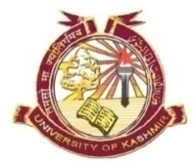
P.G Programme in Bioresources
Department of Botany
University of Kashmir, Srinagar

Online Mode Time Schedule for OE/GE courses in Bioresources

Days | Open Electives(OE) |  | General Electives(GE)
 | (2.00pm-3.00pm) |  | (3.05pm-4.05pm)
 | Semester II | Semester III | Semester II | Semester III
Friday | BR18003GE  Dr Reiaz Ul Rehman | BR18005GE  Dr. Nisar A Wani | BR18002OE  Dr. Manzoor A Mir | BR18003OE  Dr. Bashir A Lone
Saturday | BR18003GE  Dr. P A Haseeb Shah | BR18005GE  Mr Tajamul Islam | BR18002OE  Dr. Bashir A Lone | BR18003OE  Dr. Manzoor A Mir

Note: The teachers having the core courses in this time period on Friday and Saturday need to shift their clasess to the first half.

Course Code | Course Title
BR18002OE | Infectious Diseases and Human Health
BR18003OE | Infectious Diseases and Livestock Health
BR18003GE | Microbial Resources
BR18005GE | Biomedicine and Bioprospecting

Dated: 05-06-2020

